**Human Attention Modeling with Co-Adaptive Computer Interface**

* Goal:
  + Monitor human user and adapt the user interface
* Key Words
  + Task saturation
  + Attention modeling
  + Human computer interface
  + Virtual reality
  + Context switching
* Concept 1: Virtual Reality
  + Pros: more interactive environment
  + Cons: more difficult
  + Data to be collected: where user is facing inside VR, task control inputs
* Concept 2: Desktop
  + Pros: easier to implement
  + Cons: not as innovative
  + Data to be collected: task control inputs (keyboard, mouse, joystick, etc)
* Concept Design:
  + System:
    - System has n number of tasks
    - Analyzes user behavior (pattern recognition)
    - Suggests tasks that user should attend to
    - Ultimately, takes user behavior analysis and automatically sort the tasks in a queue to wait for user attention
      * Does not automatically switch the context for the user; otherwise, there may be issues in terms of interrupting a mission critical task that user may need to remain attentive to
    - System suggests tasks based on its own assertion of priority? Certain tasks may be more urgent than others?
  + User:
    - User multitasks to moderate/accomplish each task
    - Decreased user attention 🡪 decreased task efficiency
    - Forces user to allocate attention resources to the n tasks
    - Ideally, user allocates attention in such a way that overall efficiency is maximized
    - User has ability to switch tasks at whim
  + User behavior
    - Facing different sectors associated with different tasks
    - Performance on individual tasks and overall mission
  + Tasks:
    - Primary task (ie, piloting an F-35):
      * Idea 1:
        + Use joystick and pedals to control pitch, roll, and yaw
      * Idea 2:
        + Use joystick only to control pitch and roll (assume yaw is not a factor to consider)
    - Sub-tasks (ie, directing help drones):
      * Create non-aviation-related tasks that still fulfill the purpose of providing a multi-tasking scenario
      * Idea 1:
        + Drone icons need to follow an outline of a shape. As time passes, the drones tend to sway away from the original path outline and thus will occasionally require user intervention to realign the drone’s path.
        + Controls input via keyboard (+mouse?). Joystick is still used for the main task (piloting the F-35).
      * Idea 2:
        + Think of different sub tasks that actually are associated with what drones do in a practical mission
        + Examples: attack, reconnaissance, refueling, etc.
  + Context Switching:
    - Idea 1:
      * Main view/monitor is on the same hierarchical level as the subtask views
      * Context switching would happen according to user’s whim
      * Cons: this assumes that the subtasks are equally important as the main task, which is improbable as of now

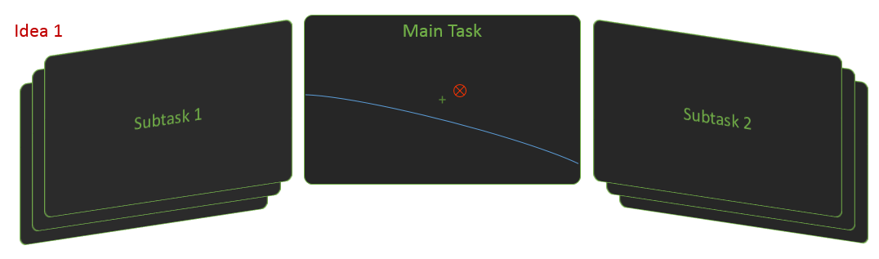

* + - Idea 2:
      * Main view/monitor is reserved for completing the main task (piloting)
      * Miniaturized secondary view/monitor is shown for subtask completion
        + Option to swap main view and secondary view for more detailed secondary task completion
        + Allows user to maintain awareness of main task at all times
        + Subtasks can be swapped out amongst the subtask hierarchy

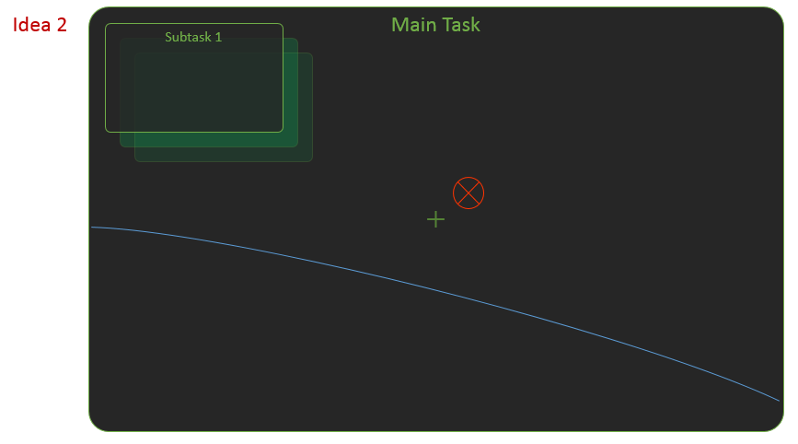

* Assumptions:
  + Allow certain level of autonomous flying and task completion
  + Ie) when focusing on a drone’s task, allow the primary task (F-35) to continue flying in the same heading, angle of attack, etc. This doesn’t totally negate the need for user oversight (because they may be following a moving target), but it doesn’t cause the plane to totally dive down when the user is not directly controlling the plane